***Youtube Playlist to be follow for understanding serial communication:***

[(1241) Serial communication of 8051 microcontroller - YouTube](https://www.youtube.com/playlist?list=PLbZJcpiFILHBRb99xhPwhJS4KFcKtP3Oe)

***Also follow the below Youtube video:***

[(1241) 8051 serial port programming using assembly and C - YouTube](https://www.youtube.com/watch?v=dOOaIg4Kb8k)

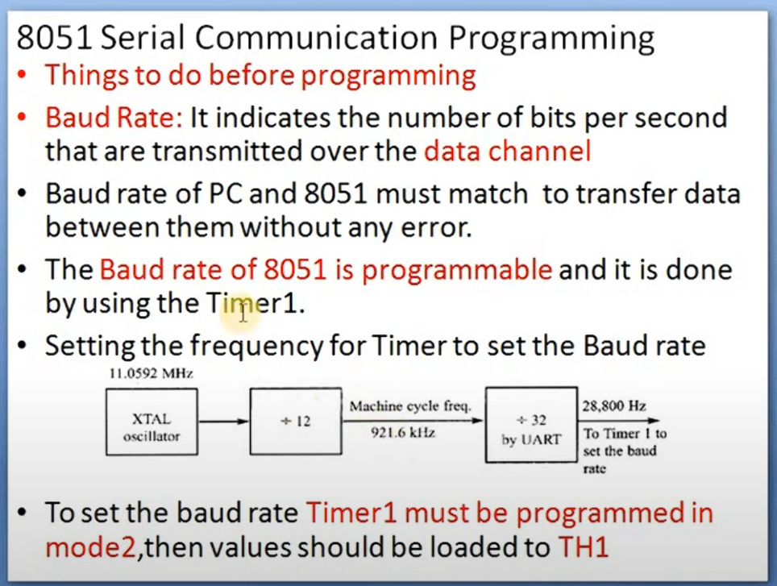

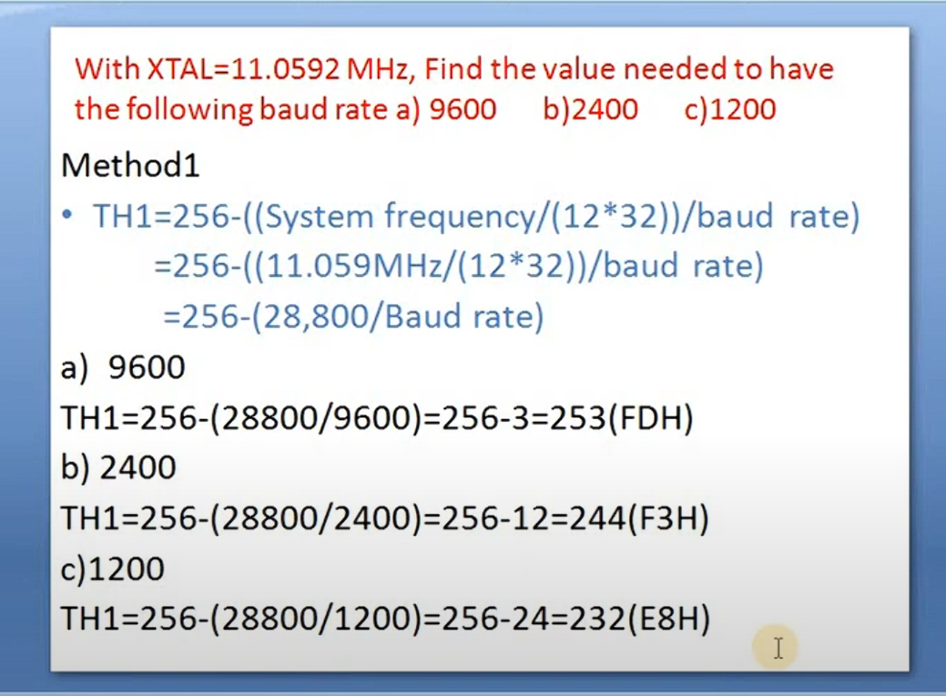

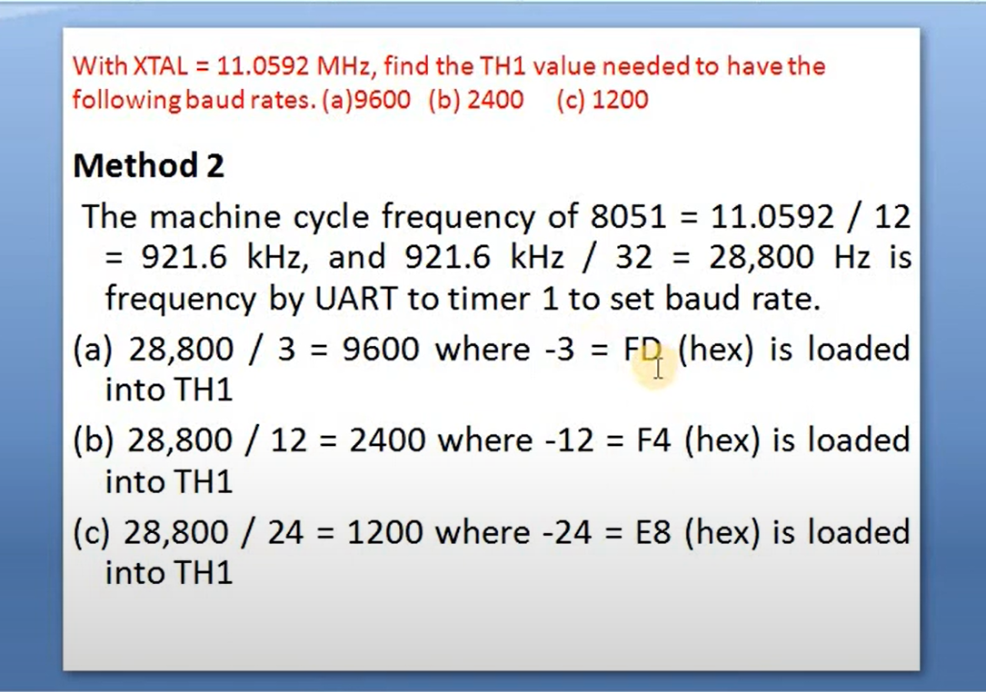

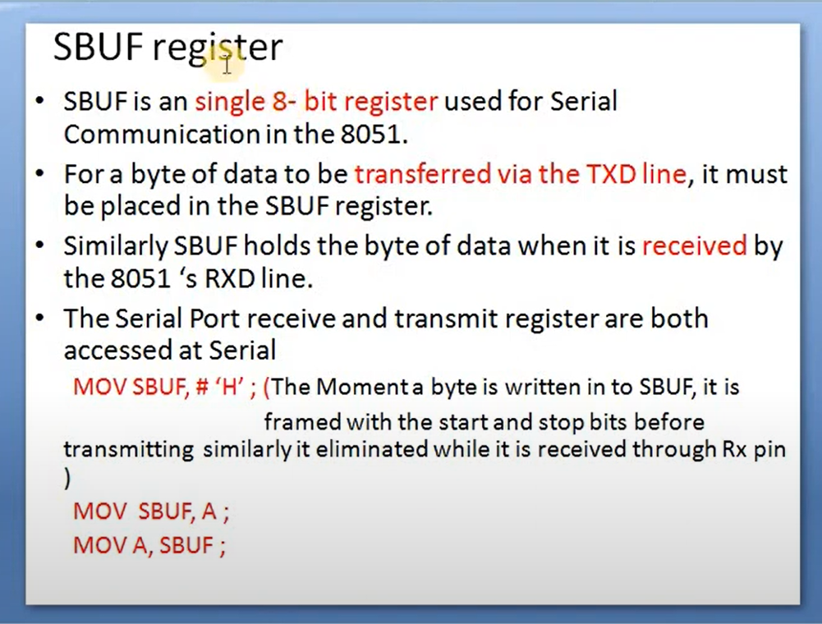

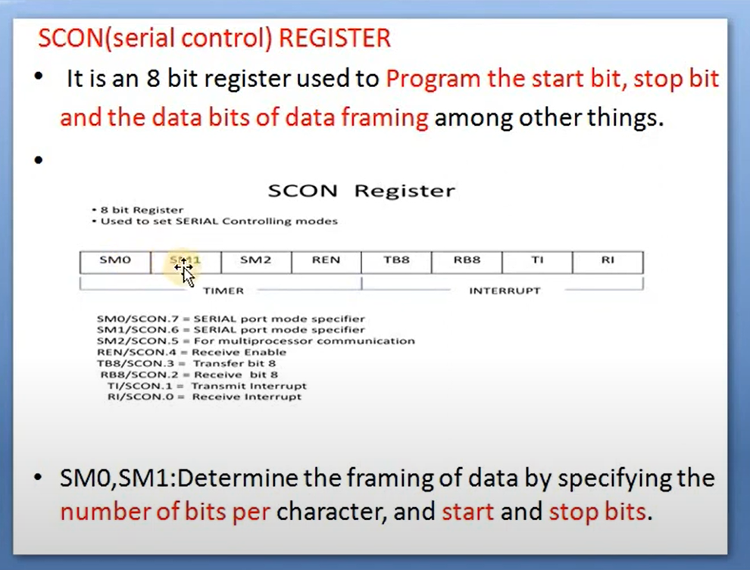

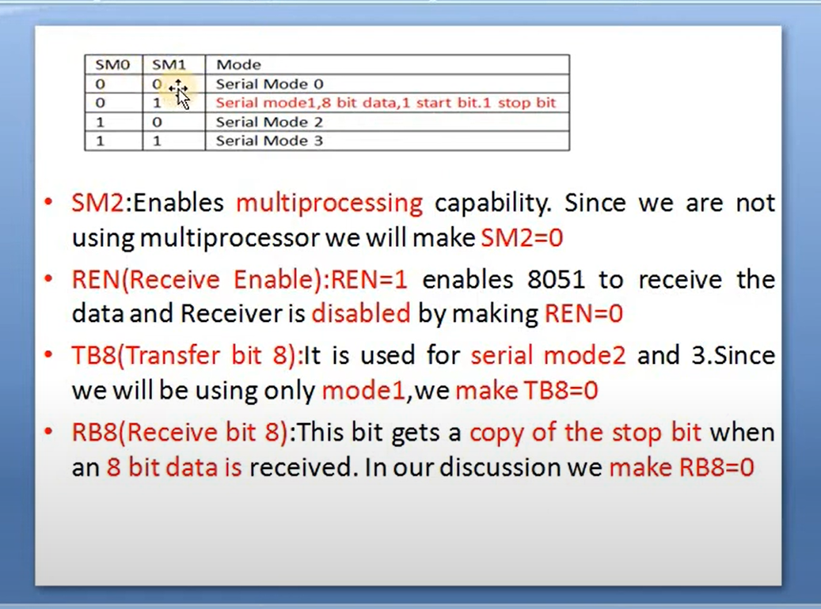

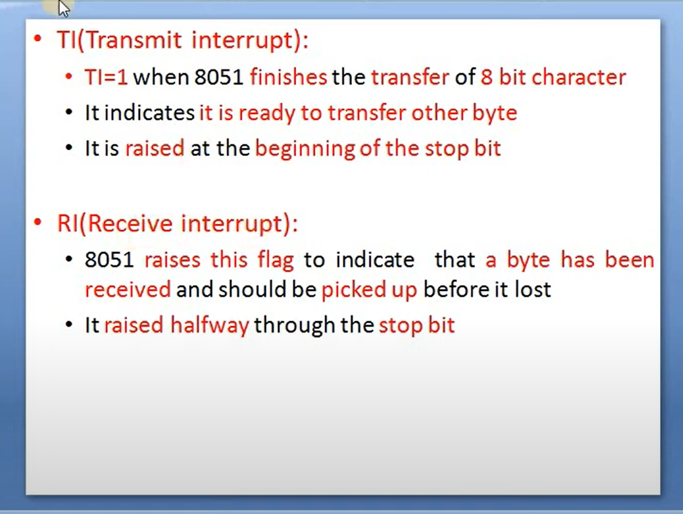

***Steps in programming 8051 to TRANSFER data Serially:***

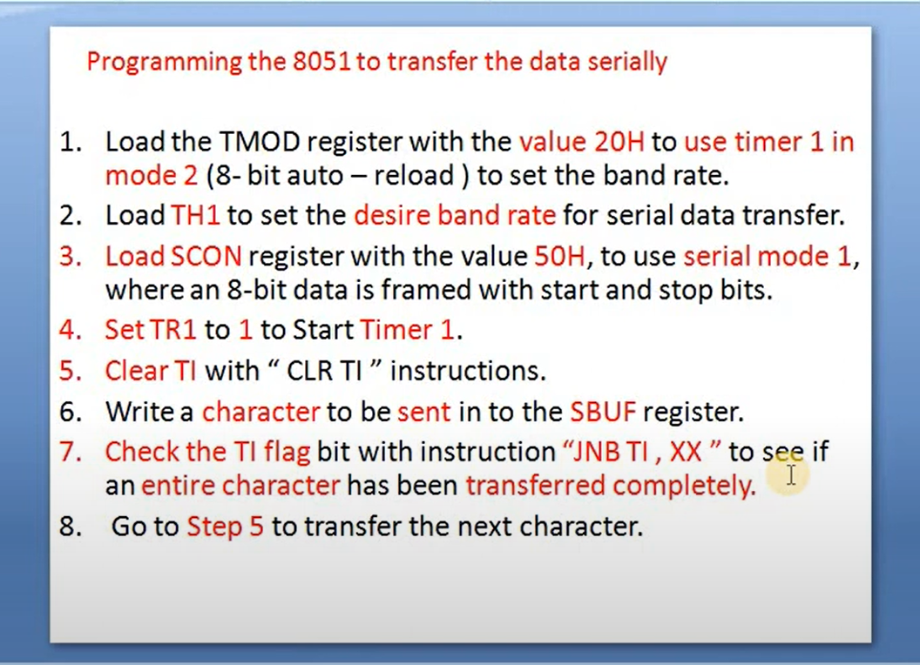

***Programing in Assembly language:***

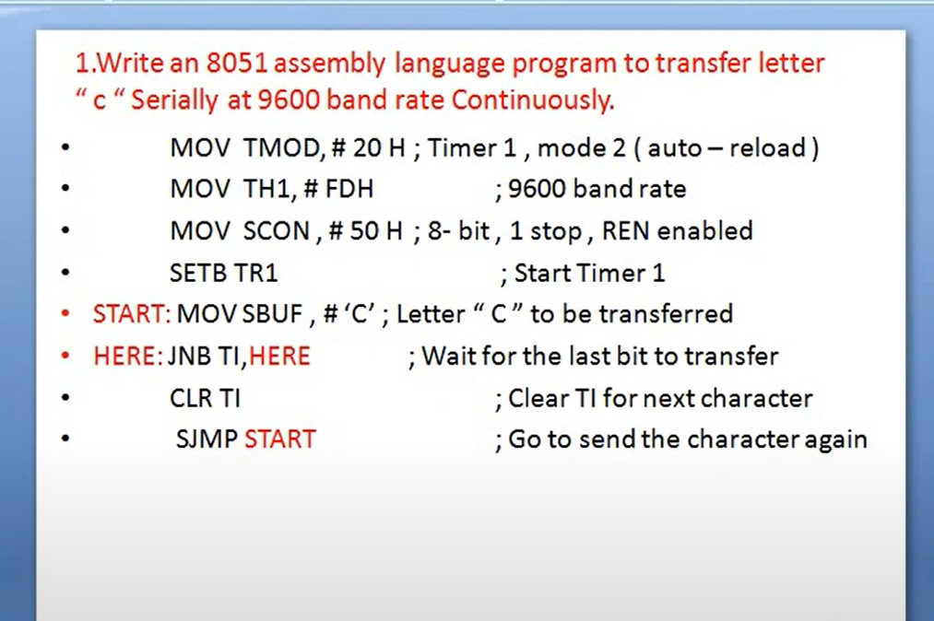

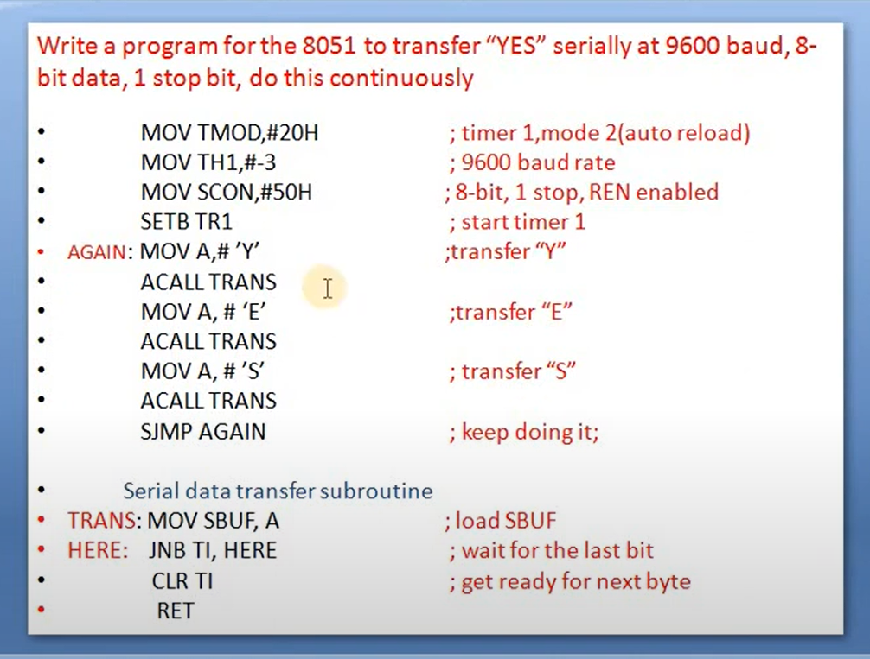

***Steps in programming 8051 to Recieve data Serially:***

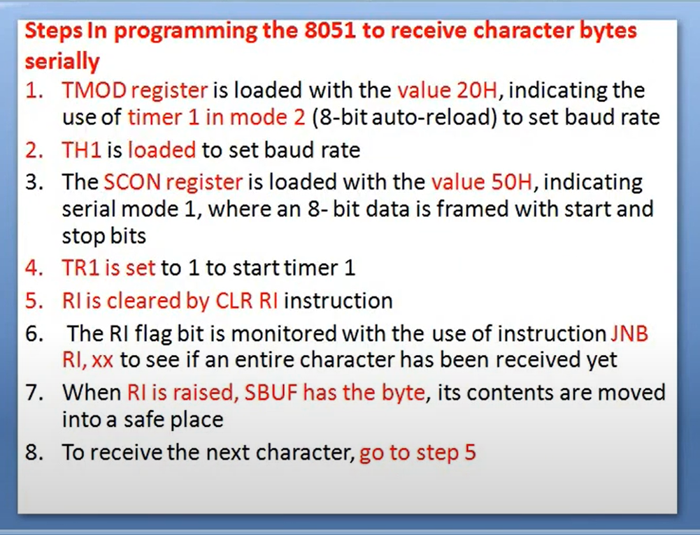

***Programing in Assembly Language:***

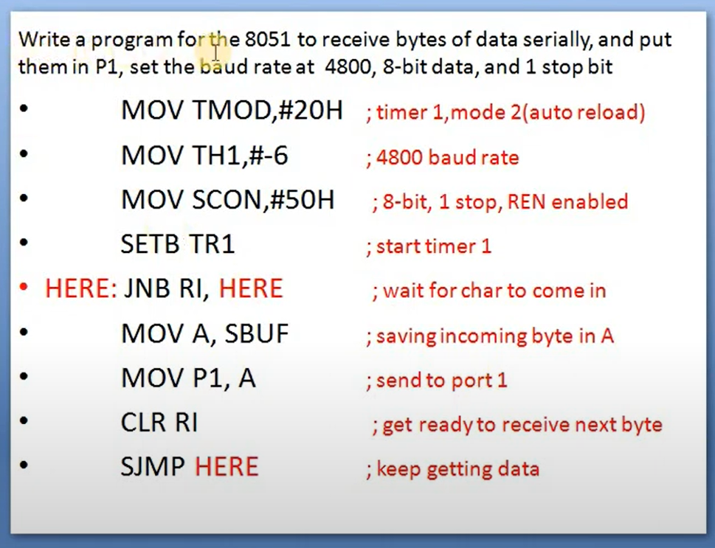

***Now Programming in C language:***

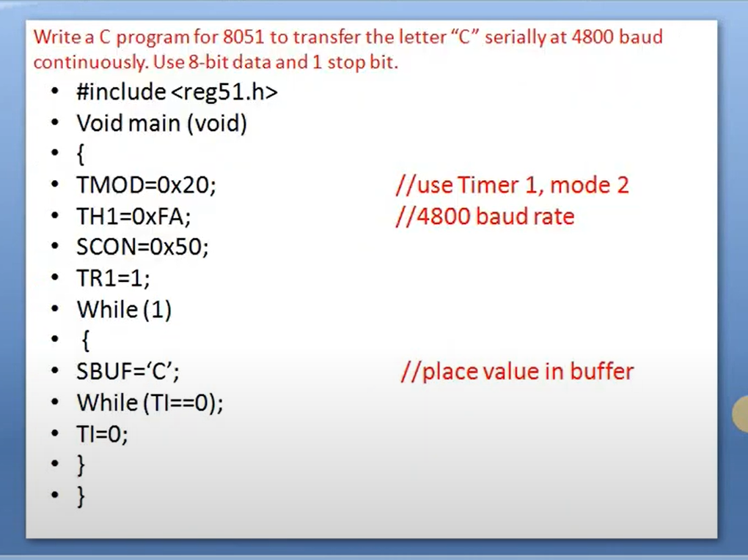

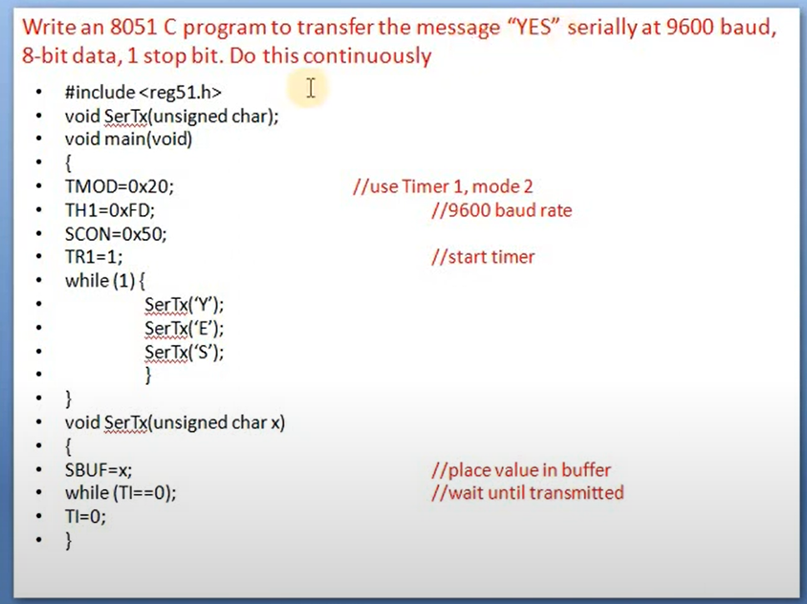

***Task_15_02:***

*Write a program to send data to PC from the microcontroller using serial port at 9600 baud rate.*

*Send any message like “Hello world”.*

*Use \n\r to see how it takes the cursor to a new line on the Hercules software e.g “Hello world\n\r”*

|  |
| --- |
|  |

**Explanation of the above Code:**

**Understanding the Code Block**

The code block you provided is used to create and display a custom character on an LCD screen connected to a microcontroller. Let's break down each part:

**CGRAM (Character Generator RAM)**

1. **CGRAM** stands for **Character Generator RAM**. This is a special area of memory inside the LCD where you can create custom characters.
2. The LCD has a set of predefined characters (like letters and numbers), but sometimes you want to show a character that isn't built-in (like a smiley face). CGRAM allows you to design and store these custom characters.

**DDRAM (Display Data RAM)**

1. **DDRAM** stands for **Display Data RAM**. This is where the characters that are actually displayed on the LCD screen are stored.
2. When you write data to DDRAM, you're telling the LCD what characters to show and where to show them on the screen.

**The Code Block Explained**

Let's go through the code line by line:

1. cmd(64);
   * This sets the **CGRAM address** to 0x40 (which is the starting address for storing the first custom character). It's like telling the LCD, "I'm going to give you the design for a new character, and I want you to start storing it at this address."
2. dat(0);
   * This sends the first row of pixel data for the custom character to the LCD. Here, 0 means that the first row of the character will be all blank (no pixels turned on).
3. dat(10);
   * This sends the second row of pixel data. The value 10 (in binary: 00001010) turns on some pixels in the second row, creating part of the custom character.
4. dat(21);
   * This sends the third row of pixel data. The value 21 (in binary: 00010101) continues to shape the custom character.
5. dat(17);
   * This sends the fourth row of pixel data. The value 17 (in binary: 00010001) adds more detail to the custom character.
6. dat(10);
   * This sends the fifth row of pixel data. Again, the value 10 turns on specific pixels.
7. dat(4);
   * This sends the sixth row of pixel data. The value 4 (in binary: 00000100) turns on a single pixel in the sixth row.
8. dat(0);
   * This sends the seventh row of pixel data. The value 0 means that the seventh row will be blank.
9. dat(0);
   * This sends the eighth (and final) row of pixel data. The value 0 means that the eighth row will also be blank.

**Moving to DDRAM**

1. cmd(0xc0);
   * This sets the DDRAM address to 0xC0, which is the starting address for the second line of the display. It's like saying, "I want to start showing characters on the second line of the screen."
2. dat(0);
   * This sends the code for the custom character stored at location 0 in CGRAM to DDRAM. It tells the LCD to display this custom character at the current position on the screen.
3. lcd_delay();
   * This introduces a delay to give the LCD time to process the commands and data. It's like saying, "Take a moment to get everything set up."

**Summary**

* **CGRAM** allows you to create custom characters by specifying the pixel data for each row.
* **DDRAM** is where the display data is stored, determining what characters appear on the screen and where.
* This code block creates a custom character by writing pixel data to CGRAM and then displays this character by writing its code to DDRAM.

**Purpose**

The purpose of this code is to:

1. Create a custom character that isn't available in the LCD's built-in character set.
2. Display this custom character on the LCD screen, specifically on the second line.

By using CGRAM and DDRAM effectively, you can make your LCD show any custom-designed characters you need for your project.